SAIGON BELLA 2025
Code: SGB2025

HIGHLIGHTS
- Give an unusual view of Saigon and Cho Lon.
- Get off the crowded tourist trail.
- Gourmet Chinese dim sum.

PROGRAM
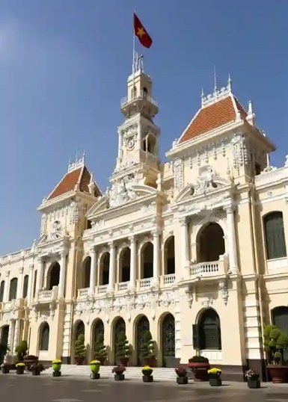
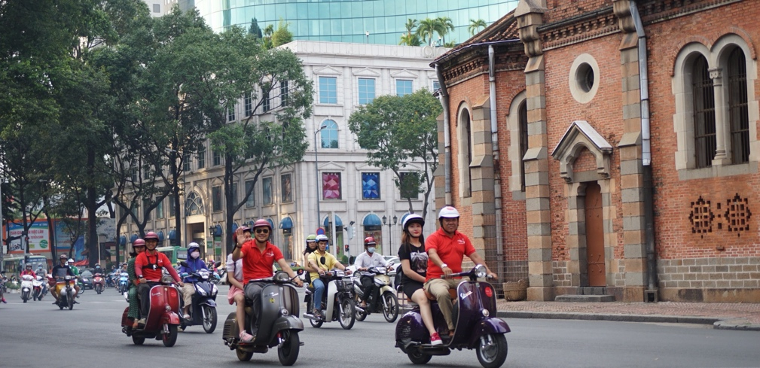
Hop on a classic Vespa for an authentic ride! Motorbikes are the preferred way to get around in Ho Chi Minh City, exploring a city on two wheels offers a much more intimate and authentic glimpse into the culture.

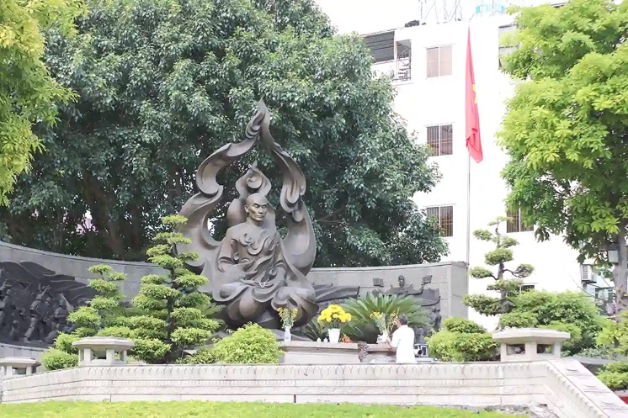
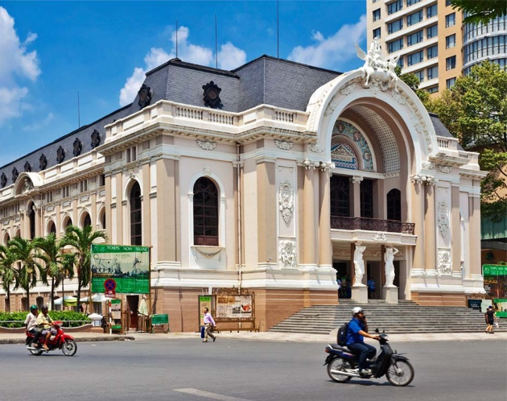
08:00am Start with hotel pickup, then ride along historic Dong Khoi Street, home to iconic colonial landmarks like Hotel Continental, Hotel Majestic, the Opera House, and the former Hôtel de Ville.

The first stop is at the Thich Quang Duc statue, commemorating the Vietnamese Buddhist monk who self-immolated in 1963 in protest against the persecution of Buddhists.

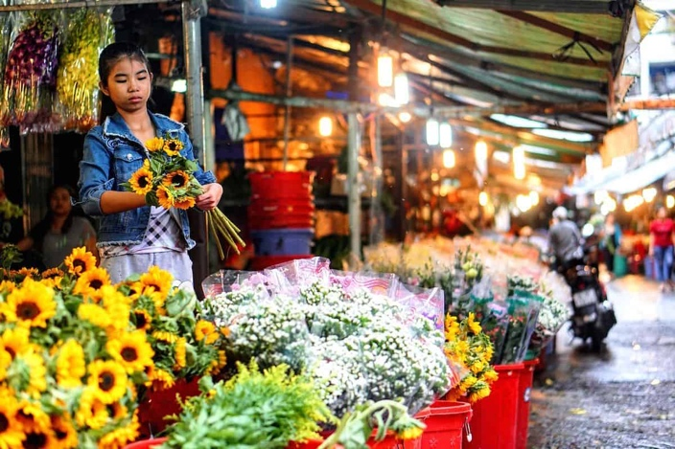
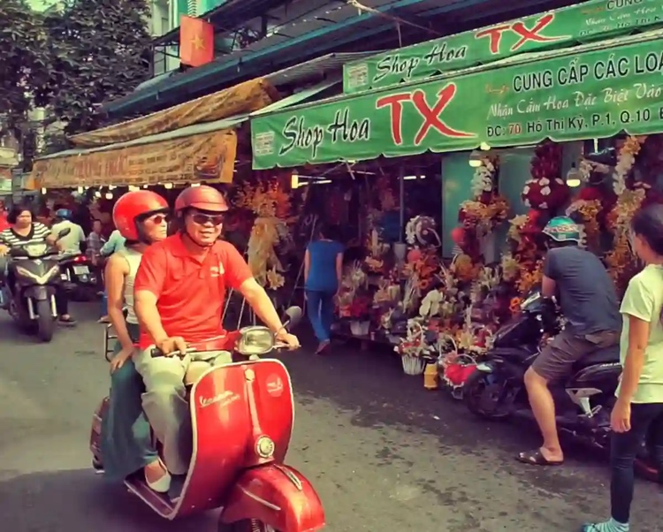

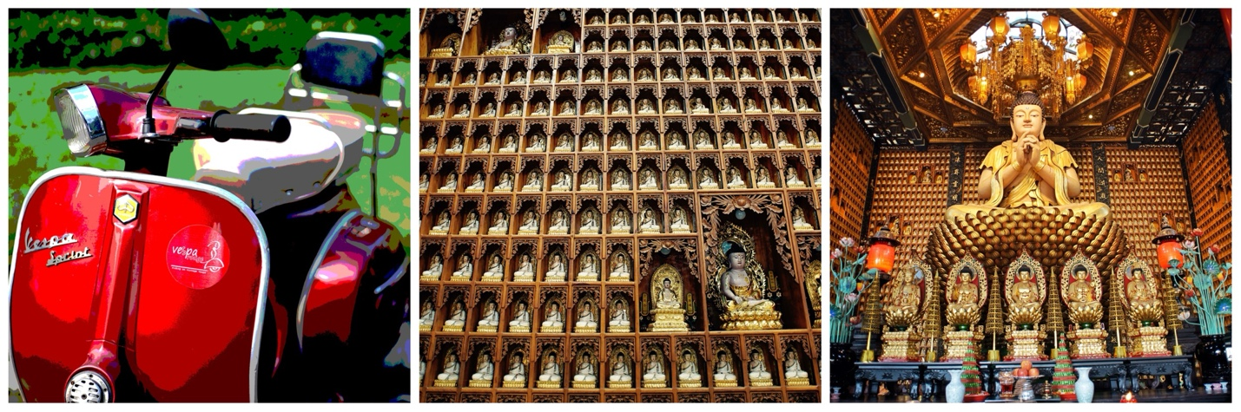
Continue your ride through Saigon’s side streets and alleys, uncovering hidden gems in Chinatown beyond the typical tour route. Enjoy a brief walk through Ho Thi Ky Flower Market to witness the vibrant daily activities before continuing on to Chinatown.
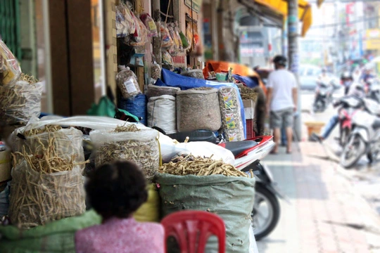
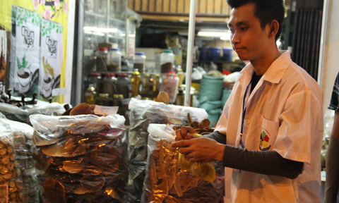
Next, stop at the Ten Thousand Buddha Pagoda to pray for good luck. Then, stroll through the herbal medicine quarter, exploring the fragrant shops along Hai Thuong Lan Ong Street.

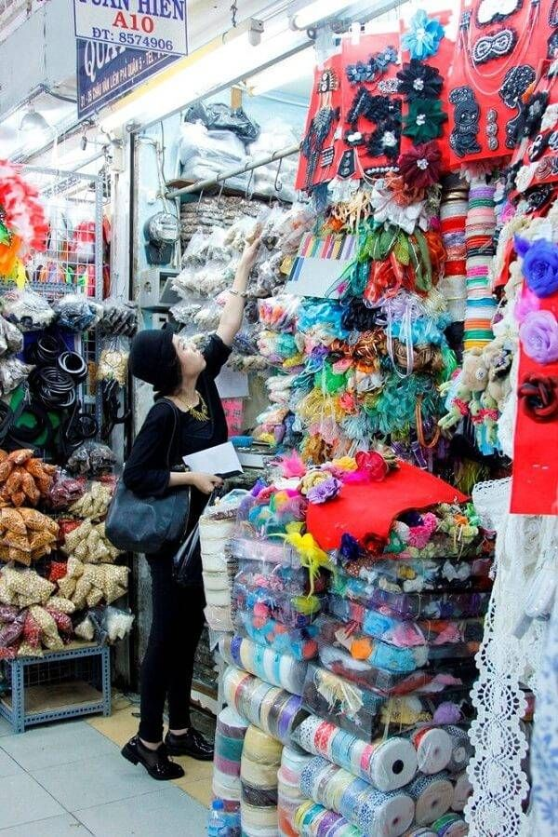
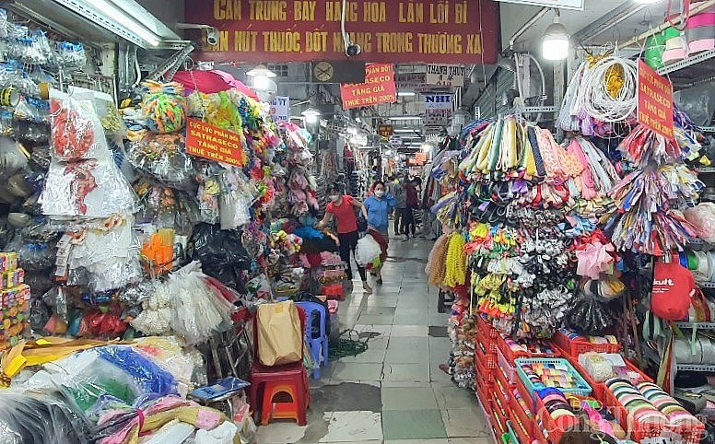
Continue the journey with a stop at Dai Quang Minh Market, a shopping paradise for fashion accessories and a wide range of unique handmade items. Your Vespa will pick you up again, taking you to Cha Tam Church, rich in historical significance, with a ride past the tobacco market along the way.
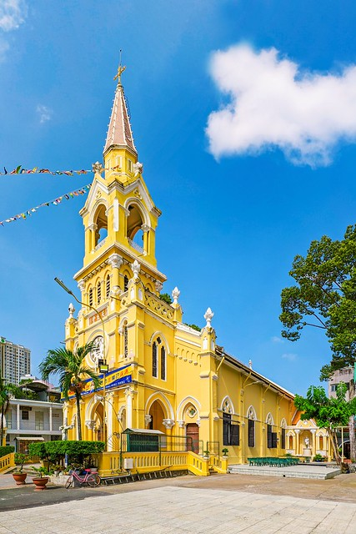
Enjoy a gourmet Chinese dim sum lunch before concluding the tour.

12:00 Tour ends at your hotel.
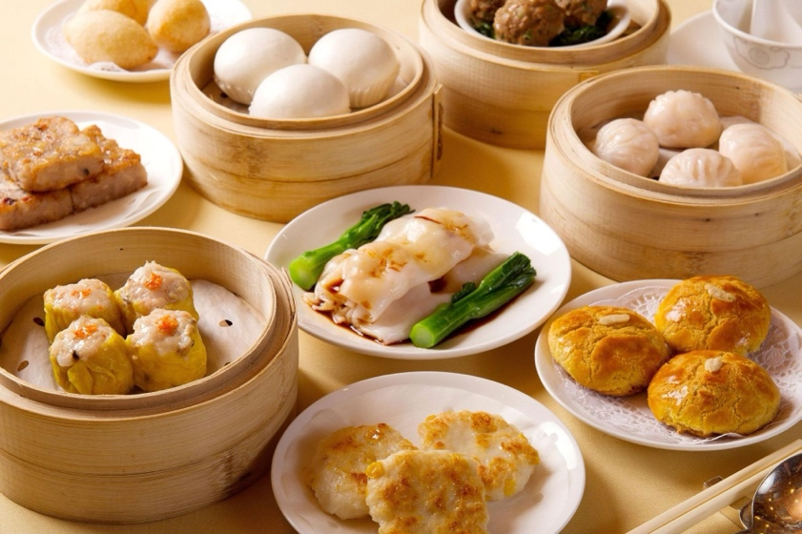

SIGHTSEEINGS
- Thich Quang Duc statue.
- Lively flower market.
- Ten thousand Buddha pagoda.
- Herbal medicine quarter.
- Fashion accessories market.
- Cha Tam church & tobacco market.
- Dim sum lunch.

TOUR DURATION 4 hours
Tour starting 08.00am
Tour ending 12.00pm

INCLUSIVE OF
- 4-hour excursion
- Private tour
- Sightseeing as per program
- Dim sum lunch.
- Cold drink (1 unit per pax)
- Vespa & Tour Guide
- Helmets & Mask
- Cold towels & Mineral water
- Insurance

VESPA ROUGE Co. Ltd
Hotline: +84 (0) 918050571
Mobile: +84 (0) 903943081
Email: reservations@vesparouge.com
Web: vesparouge.com

