**SAIGON GOOD MORNING 2025**

Code: SGM2025

**HIGHLIGHTS**

* Give an unusual view of Saigon and Cho Lon.
* Relaxing experience.
* Get off the crowded tourist trail.
* Savor Vietnamese drink.

**PROGRAM**

Hop on a classic Vespa and get ready to explore the hidden gems of Saigon and Chinatown, far beyond a typical city tour!

08:30 Start your journey as you're picked up from your hotel and ride through Saigon's charming streets on a Vespa.

Ride along historic Dong Khoi Street, home to iconic colonial landmarks like Hotel Continental, Hotel Majestic, the Opera House, and the former Hôtel de Ville.

The first stop is at the Thich Quang Duc statue, commemorating the Vietnamese Buddhist monk who self-immolated in 1963 in protest against the persecution of Buddhists.

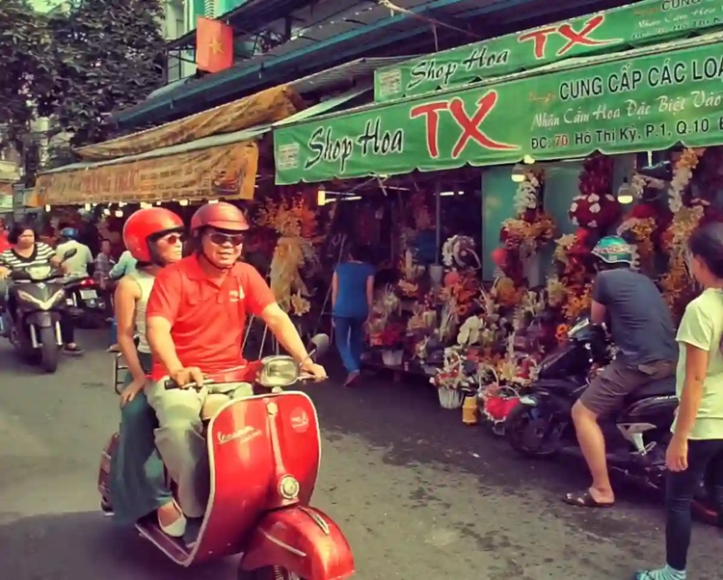

Continue your Vespa ride through side streets, passing Ho Thi Ky flower market to Chinatown.

Discover hidden corners, observe daily life, and visit Ong Bon Temple to join the votive burning ritual.

Explore Cha Tam Church, a unique blend of Chinese and Gothic architecture, reflecting the rich history of the area.

Stroll along the herbal medicine street, exploring shops filled with rich aromas.

Enjoy a cooling herbal drink “sam bo luong” before heading back to your hotel.

11:00 Tour ends at your hotel.

**SIGHTSEEINGS**

* Thich Quang Duc statue.
* Lively flower market.
* Ong Bon temple, votive burning ritual.
* Cha Tam church
* Refreshing a cooling herbal drink “sam bo luong”

**TOUR DURATION 2.5 hours**

Tour starting 08.30am

Tour ending 11.00am

**INCLUSIVE OF**

* 2.5-hour excursion
* Private tour
* Sightseeing as per program
* Cold drink (1 unit per pax)
* Vespa & Tour Guide
* Helmets & Mask
* Cold towels & Mineral water
* Insurance

**VESPA ROUGE Co. Ltd**

Hotline: [+84 (0) 918050571](tel:+84%20918050571)

Mobile: [+84 (0) 903943081](tel:+84%20903943081)

Email: [reservations@vesparouge.com](mailto:reservations@vesparouge.com)

Attn: Mr. Tâm / Manager

Web: [vesparouge.com](http://vesparouge.com/)