**SAIGON VETERAN 2025**

Code: SGV2025

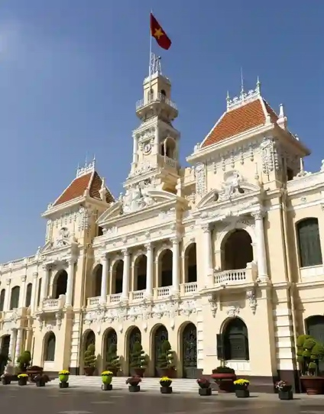**HIGHLIGHTS**

* The War Remnants Museum.
* The burning monk 1963.
* The secret weapon storage.
* The arrest of President Ngo Dinh Diem.

**PROGRAM**

Take a Vespa ride back in time to explore historical sites and stories connected to the Vietnam War.

08:00 am – Begin the tour with a Vespa ride along historic Catinat Street, passing iconic landmarks such as the Continental Hotel, the Opera House, the Hôtel de Ville, the famous Rex Hotel (known for the 'five o'clock follies' during the Vietnam War) and the historic Caravelle Hotel with its Saigon Saigon Bar (a gathering spot for war correspondents during daily briefings)...

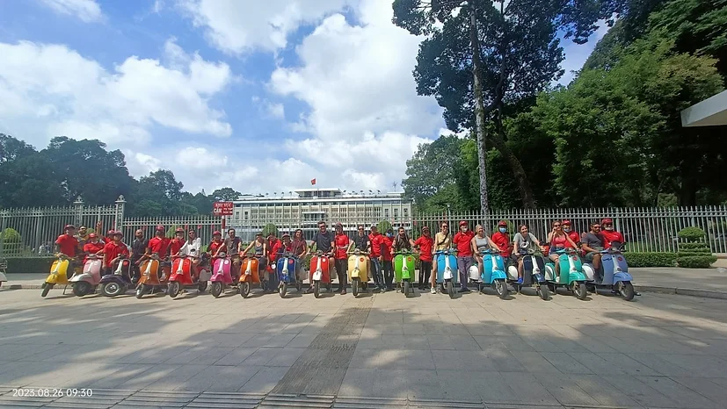

Conclude this section with a photo stop at the Reunification Palace.

First, visit the War Remnants Museum, featuring exhibits related to the Vietnam War.

Next, stop at the statue of Thich Quang Duc, the Vietnamese Buddhist monk who self-immolated in Saigon on June 11, 1963, in protest.

Continue the Vespa ride through narrow alleys for an in-depth look at local life in Saigon.

The excursion leads you to a secret weapons storage site once used by Team 5 Saigon commandos to gather arms for the Tet Offensive on January 30, 1968.

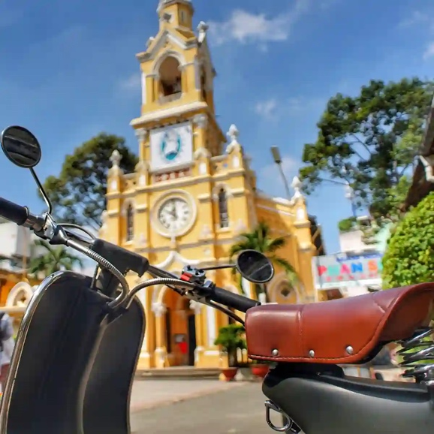

The yellow spire of Cha Tam Church will then guide you to the place where President Ngo Dinh Diem and his brother sought refuge in their final, failed escape from a coup on November 1, 1963.

Conclude the tour with a gourmet Chinese dim sum lunch before returning to your hotel.

12:00 Tour ends at your hotel.

**SIGHTSEEINGS**

* The War Remnants Museum.
* The burning monk 1963.
* The secret weapon storage.
* The Cha Tam church.
* Dim sum lunch.

**TOUR DURATION 4 hours**

Tour starting 08.00am

Tour ending 12.00pm

**INCLUSIVE OF**

* 4-hour excursion
* Private tour
* Sightseeing as per program
* Cold drink (1 unit per pax)
* Chinese dim sum lunch
* Vespa & Tour Guide
* Helmets & Mask
* Cold towels & Mineral water
* Insurance

**VESPA ROUGE Co. Ltd**

Hotline: [+84 (0) 918050571](tel:+84%20918050571)

Mobile: [+84 (0) 903943081](tel:+84%20903943081)

Email: [reservations@vesparouge.com](mailto:reservations@vesparouge.com)

Attn: Mr. Tâm / Manager

Web: [vesparouge.com](http://vesparouge.com/)