**SAIGON BY NIGHT 2025**

Code: SN2025

**HIGHLIGHTS**

* A ride of your life
* Street food adventure
* Saigon night life & live music

**PROGRAM**

Are you ready for a ride of your life? Hop on the back of a vintage Vespa scooter and experience Saigon nightlife the way locals do.

06.00pm You will be picked up from your hotel and start your Vespa night trip by mingling in the crowd of locals going home after work. You will witness Saigon's rush hour traffic. Roads are mega-loaded with scooters, cars, bicycles, buses...and they honk every two seconds.

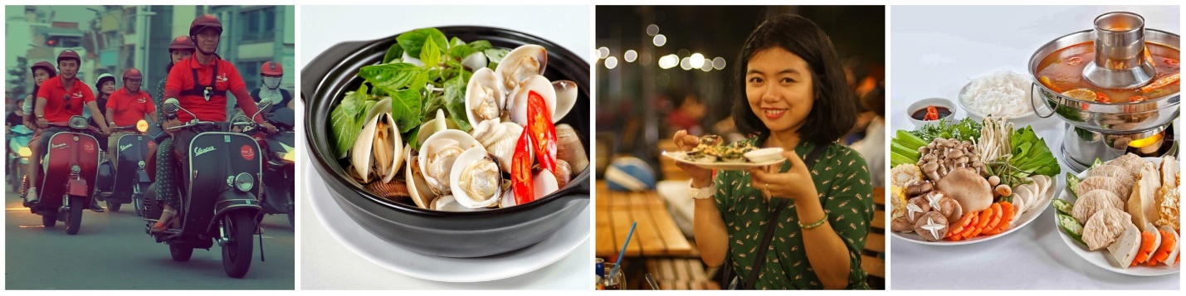It's chaotic, noisy, fascinating.

A welcome drink on a bridge overlooking the iconic tower awaits you.

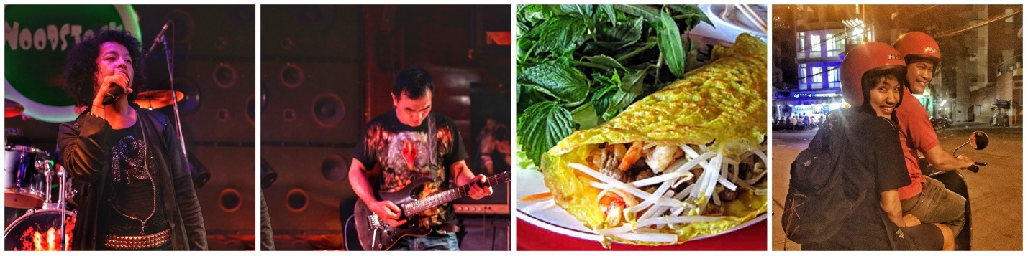There is no better way to be immersed in the culture of Vietnam than by exploring side streets and back alleys where the local people congregate, feeling the warmth of genuine interaction.

First stop at a “local favorite” restaurant to sample unique and tasty seafood. Continue the ride to your next restaurant where you will enjoy the authentic Vietnamese food that can’t miss.

Before ending the tour you will discover the diversity between the local cafés with Vietnamese music and popular bars with acoustic music.

22.00 return to hotel. End tour.

**TOUR DURATION 4 hours**

Tour starting 06.00pm

Tour ending 10.00pm

**INCLUSIVE OF**

‣ 4-hour excursion

‣ Private tour

‣ All-you-can-eat & free flow beers, drinks…

‣ Vespa & Tour Guide

‣ Helmets & Mask & Raincoats

‣ Insurance

**VESPA ROUGE Co. Ltd**

Hotline: [+84 (0) 918050571](tel:+84%20918050571)

Mobile: [+84 (0) 903943081](tel:+84%20903943081)

Email: [reservations@vesparouge.com](mailto:reservations@vesparouge.com)

Web: [vesparouge.com](http://vesparouge.com/)